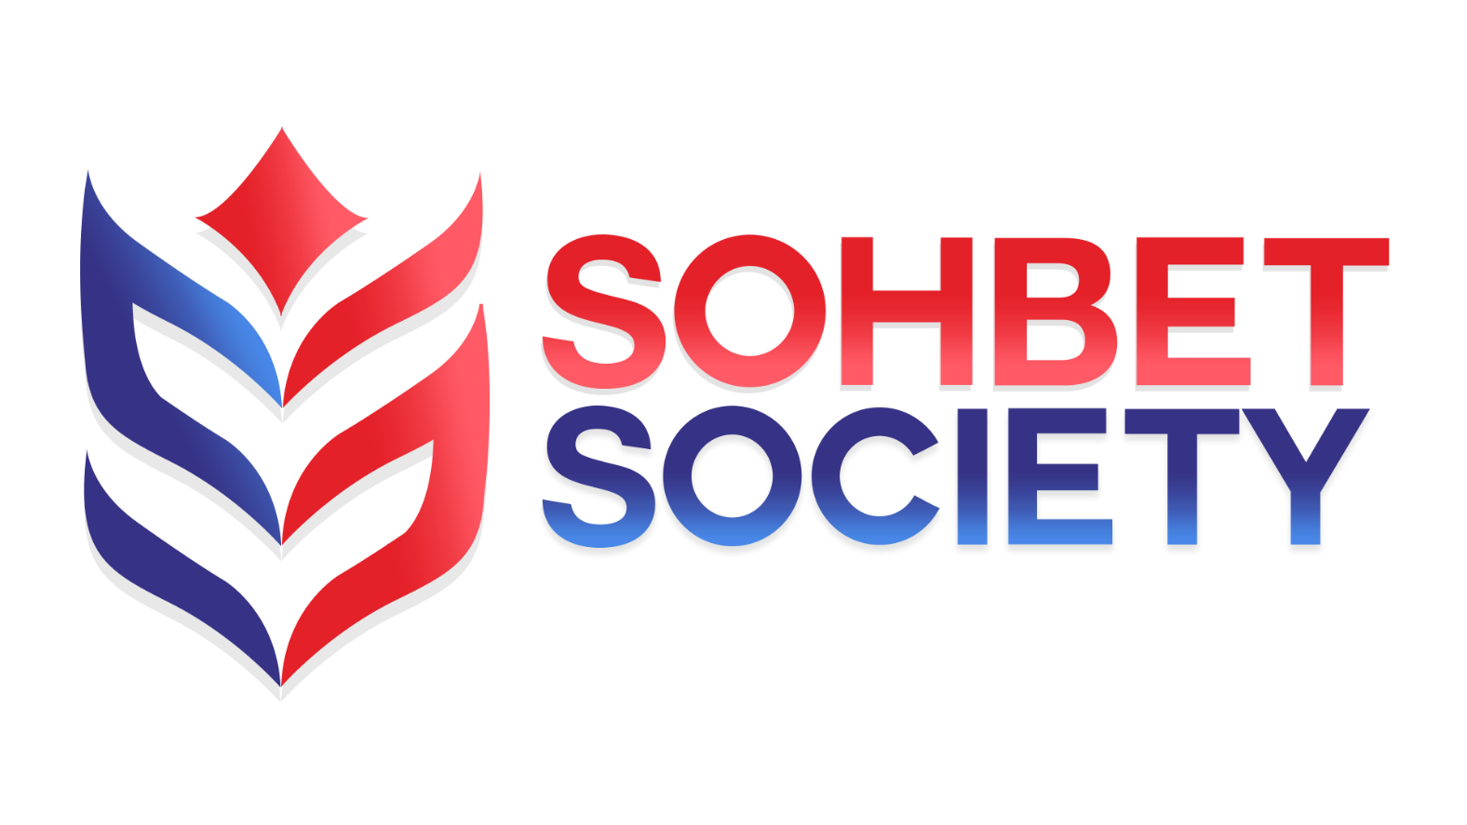

SOHBET SOCIETY
SOCIAL MEDIA POLICY

A guide for staff on using social media to promote the work of Sohbet Society and in a personal capacity.

This policy will be reviewed on an ongoing basis, at least once a year. Sohbet Society will amend this policy, following consultation, where appropriate.

Contents

Introduction 3
What is social media? 3
Why do we use social media? 3
Why do we need a social media policy? 3
Setting out the social media policy 3
Internet access and monitoring usage 3
Point of contact for social media 3
Which social media channels do we use? 3
Guidelines 4
Using Sohbet Society's social media channels — appropriate conduct 4
Use of personal social media accounts — appropriate conduct 5
Further guidelines 6
Libel 7
Copyright law 7
Confidentiality 7
Discrimination and harassment 7
Lobbying Act 7
Use of social media in the recruitment process 7
Protection and intervention 8
Under 18s and vulnerable people 8
Responsibilities and beach of policy 8
Public Interest Disclosure 8

Introduction

What is social media?
Social media is the term given to web-based tools and applications which enable users to create and share content (words, images and video content), and network with each other through the sharing of information, opinions, knowledge and common interests. Examples of social media include Facebook, Twitter and Instagram.

Why do we use social media?
Social media is essential to the success of communicating Sohbet Society’s work. It is important for some staff to participate in social media to engage with our audience, participate in relevant conversations and raise the profile of Sohbet Society's work.

Why do we need a social media policy?
The difference between a personal and professional opinion can be blurred on social media, particularly if you're discussing issues relating to Sohbet Society's work. While we encourage the use of social media, we have certain standards, outlined in this policy, which we require everyone to observe. Publication and commentary on social media carry similar obligations to any other kind of publication or commentary in the public domain.

This policy is intended for all staff members of all levels, volunteers and trustees and applies to content posted on both a Sohbet Society device and a personal device. Before engaging in work-related social media activity, staff must read this policy.

Setting out the social media policy
This policy sets out guidelines on how social media should be used to support the delivery and promotion of Sohbet Society, and the use of social media by staff in both a professional and personal capacity. It sets out what you need to be aware of when interacting in these spaces and is designed to help staff support and expand our official social media channels, while protecting the charity and its reputation and preventing any legal issues.

Internet access and monitoring usage
There are currently no access restrictions to any of our social media sites in the Sohbet Society office. However, when using the internet at work, it is important that staff refer to our IT Policy. You are permitted to make reasonable and appropriate use of personal social media activity during your lunch breaks. But usage should not be excessive and interfere with your duties.

Point of contact for social media
Our Social Media Team is responsible for the day-to-day publishing, monitoring and management of our social media channels. If you have specific questions about any aspect of these channels, speak to the COO. No other staff member can post content on Sohbet Society's official channels without the permission of the COO.

Which social media channels do we use?
Sohbet Society uses the following social media channels:

Twitter, Facebook, Instagram: @mentorwiseuk

Guidelines

Using Sohbet Society's social media channels — appropriate conduct

1. Social Media Team is responsible for setting up and managing Sohbet Society's social media channels. Only those authorized to do so by the COO will have access to these accounts.

2. Our social media team responds to comments Monday-Friday, 9am-5pm, and then on evenings and weekends we have a social media out-of-hours rota, covered by the team.

3. Be an ambassador for our brand. Staff should ensure they reflect Sohbet Society values in what they post and use our tone of voice. Our brand guidelines set out our tone of voice that all staff should refer to when posting content on Sohbet Society's social media channels.

4. Make sure that all social media content has a purpose and a benefit for Sohbet Society, and accurately reflects Sohbet Society’s agreed position.

5. Bring value to our audience(s). Answer their questions, help and engage with them

6. Take care with the presentation of content. Make sure that there are no typos, misspellings or grammatical errors. Also check the quality of images.

7. Always pause and think before posting. That said, reply to comments in a timely manner, when a response is appropriate.

8. If staff outside of Social Media Team wish to contribute content for social media, whether non-paid for or paid for advertising, they should speak to the Social Media Team about this.

9. Staff shouldn't post content about supporters or service users without their express permission. If staff are sharing information about supporters, service users or third-party organizations, this content should be clearly labelled so our audiences know it has not come directly from Sohbet Society. If using interviews, videos or photos that clearly identify a child or young person, staff must ensure they have the consent of a parent or guardian before using them on social media.

10. Always check facts. Staff should not automatically assume that material is accurate and should take reasonable steps where necessary to seek verification, for example, by checking data/statistics and being wary of photo manipulation.

11. Be honest. Say what you know to be true or have a good source for. If you've made a mistake, don't be afraid to admit it.

12. Staff should refrain from offering personal opinions via Sohbet Society's social media accounts, either directly by commenting or indirectly by 'liking', 'sharing' or 'retweeting'. If you are in doubt about Sohbet Society's position on a particular issue, please speak to Social Media Team.

13. It is vital that Sohbet Society does not encourage others to risk their personal safety or that of others, to gather materials. For example, a video of a stunt.

14. Staff should not encourage people to break the law to supply material for social media, such as using unauthorized video footage. All relevant rights for usage must be obtained before publishing material.

15. Staff should not set up other Facebook groups or pages, Twitter accounts or any other social media channels on behalf of Sohbet Society. This could confuse messaging and brand awareness. By having official social media accounts in place, the Social Media Team can ensure consistency of the brand and focus on building a strong following.

16. Sohbet Society is not a political organization and does not hold a view on party politics or have any affiliation with or links to political parties. We have every right to express views on policy, including the policies of parties, but we can't tell people how to vote.

17. If a complaint is made on Sohbet Society's social media channels, staff should seek advice from the Management Board before responding. If they are not available, then staff should speak to the COO.

18. Sometimes issues can arise on social media which can escalate into a crisis situation because they are sensitive or risk serious damage to the charity's reputation. Examples might include: Usage of people’s pictures or videos without their consent, hacked accounts. The nature of social media means that complaints are visible and can escalate quickly. Not acting can be detrimental to the charity.

The Social Media Team regularly monitors our social media spaces for mentions of Sohbet Society so we can catch any issues or problems early. If there is an issue that could develop or has already developed into a crisis situation, the Social Media Team will do the following:
- Assess the situation
- Understand the scope
- Inform COO
- Inform Management board
- If the situation is a crime inform public bodies (e.g. Police, Charity Commission)

If any staff outside of the Social Media Team become aware of any comments online that they think have the potential to escalate into a crisis, whether on Sohbet Society's social media channels or elsewhere, they should speak to the Social Media team or COO immediately.

Use of personal social media accounts — appropriate conduct

This policy does not intend to inhibit personal use of social media but instead flags up those areas in which conflicts might arise. Sohbet Society staff are expected to behave appropriately, and in ways that are consistent with Sohbet Society's values and policies, both online and in real life.

1. Be aware that any information you make public could affect how people perceive Sohbet Society. You must make it clear when you are speaking for yourself and not on behalf of Sohbet Society. If you are using your personal social media accounts to promote and talk about Sohbet Society's work, you must use a disclaimer such as: "The views expressed on this site are my own and don't necessarily represent Sohbet Society's positions, policies or opinions."

2. Staff who have a personal blog or website which indicates in any way that they work at Sohbet Society should discuss any potential conflicts of interest with their line manager and the Social Media Team. Similarly, staff who want to start blogging and wish to say that they work for Sohbet Society should discuss any potential conflicts of interest with their line manager and the Social Media Team.

3. Those in senior management, and specialist roles where they are well known in their field of expertise, must take particular care as personal views published may be misunderstood as expressing Sohbet Society's view.

4. Use common sense and good judgement. Be aware of your association with Sohbet Society and ensure your profile and related content is consistent with how you wish to present yourself to the general public, colleagues, partners and funders.

5. If a staff member is contacted by the press about their social media posts that relate to Sohbet Society, they should talk to the Social Media Team immediately and under no circumstances respond directly.

6. Sohbet Society is not a political organization and does not hold a view on party politics or have any affiliation with or links to political parties. When representing Sohbet Society, staff are expected to hold Sohbet Society's position of neutrality. Staff who are politically active in their spare time need to be clear in separating their personal political identity from Sohbet Society, and understand and avoid potential conflicts of interest.

7. Never use Sohbet Society's logos or trademarks unless approved to do so. Permission to use logos should be requested from the Social Media Team.

8. Always protect yourself and the charity. Be careful with your privacy online and be cautious when sharing personal information. What you publish is widely accessible and will be around for a long time, so do consider the content carefully. When you are using social media sites at work, it is important that you do so safely. You can find more information on your responsibilities when using our computer systems in our IT Policy.

11. Think about your reputation as well as the charity's. Express your opinions and deal with differences of opinion respectfully. Don't insult people or treat them badly. Passionate discussions and debates are fine, but you should always be respectful of others and their opinions. Be polite and the first to correct your own mistakes.

12. We encourage staff to share tweets and posts that we have issued. When online in a personal capacity, you might also see opportunities to comment on or support Sohbet Society and the work we do. Where appropriate and using the guidelines within this policy, we encourage staff to do this as it provides a human voice and raises our profile. However, if the content is controversial or misrepresented, please highlight this to the Social Media Team who will respond as appropriate.

Further guidelines

Libel
Libel is when a false written statement that is damaging to a person's reputation is published online or in print. Whether staff are posting content on social media as part of their job or in a personal capacity, they should not bring Sohbet Society into disrepute by making defamatory comments about individuals or other organizations or groups.

Copyright law
It is critical that all staff abide by the laws governing copyright, under the Copyright, Designs and Patents Act 1988. Never use or adapt someone else's images or written content without permission. Failing to acknowledge the source/author/resource citation, where permission has been given to reproduce content, is also considered a breach of copyright.

Confidentiality
Any communications that staff make in a personal capacity must not breach confidentiality. For example, information meant for internal use only or information that Sohbet Society is not ready to disclose yet. For example, a news story that is embargoed for a particular date. Please refer to our Privacy Policy for further information.

Discrimination and harassment
Staff should not post content that could be considered discriminatory against, or bullying or harassment of, any individual, on either an official Sohbet Society social media channel or a personal account. For example:
- making offensive or derogatory comments relating to sex, gender, race, disability, sexual orientation, age, religion or belief
- using social media to bully another individual
- posting images that are discriminatory or offensive or links to such content

Lobbying Act
Charities are legally allowed to campaign to bring about a change in policy or law to further their organizational purpose. In most cases, spending on charity campaigns that are in accordance with charity law will not be regulated under electoral law. However, the Lobbying Act, which was passed in January 2014, states that during national elections (known as regulated periods) spending on campaigning activities may be regulated.

Charities which spend more than £20,000 in England or £10,000 in Scotland, Wales or Northern Ireland, during the regulated period, need to register with the Electoral Commission. To abide by the Lobbying Act, campaigning activities on social media must not be seen as intending to influence people's voting choice. During these periods, all campaigning activity will be reviewed by the COO.

Use of social media in the recruitment process
Recruitment should be carried out in accordance with the Recruitment Policy, and associated procedures and guidelines. Any advertising of vacancies should be done through HR and the Recruitment Team.

There should be no systematic or routine checking of candidate's online social media activities during the recruitment process, as conducting these searches might lead to a presumption that an applicant's protected characteristics, such as religious beliefs or sexual orientation, played a part in a recruitment decision. This is in line with Sohbet Society's Equal Opportunities Policy.

Protection and intervention
The responsibility for measures of protection and intervention lies first with the social networking site itself. Different social networking sites offer different models of interventions in different areas. For more information, refer to the guidance available on the social networking site itself. For example, Facebook. However, if a staff member considers that a person/people is/are at risk of harm, they should report this to the COO immediately.

Under 18s and vulnerable people
Young and vulnerable people face risks when using social networking sites. They may be at risk of being bullied, publishing sensitive and personal information on their profiles, or from becoming targets for online grooming.

Where known, when communicating with young people under 18-years-old via social media, staff should ensure the online relationship with Sohbet Society follows the same rules as the offline 'real-life' relationship. Staff should ensure that young people have been made aware of the risks of communicating and sharing information online, and given guidance on security/privacy settings as necessary. Staff should also ensure that the site itself is suitable for the young person and Sohbet Society content and other content is appropriate for them. Please refer to our Safeguarding Policy.

Responsibilities and beach of policy
Everyone is responsible for their own compliance with this policy. Participation in social media on behalf of Sohbet Society is not a right but an opportunity, so it must be treated seriously and with respect. For staff, breaches of policy may incur disciplinary action, depending on the severity of the issue. Please refer to our employee handbook for further information on disciplinary procedures. Staff who are unsure about whether something they propose to do on social media might breach this policy, should seek advice from the COO.

Public Interest Disclosure
Under the Public Interest Disclosure Act 1998, if a staff member releases information through Sohbet Society's social media channels that is considered to be in the interest of the public, Sohbet Society's Whistleblowing Policy must be initiated before any further action is taken.

Monitoring

Review Date | 29/03/2021
Next Review Date | 29/03/2022
Review Author | AEK

