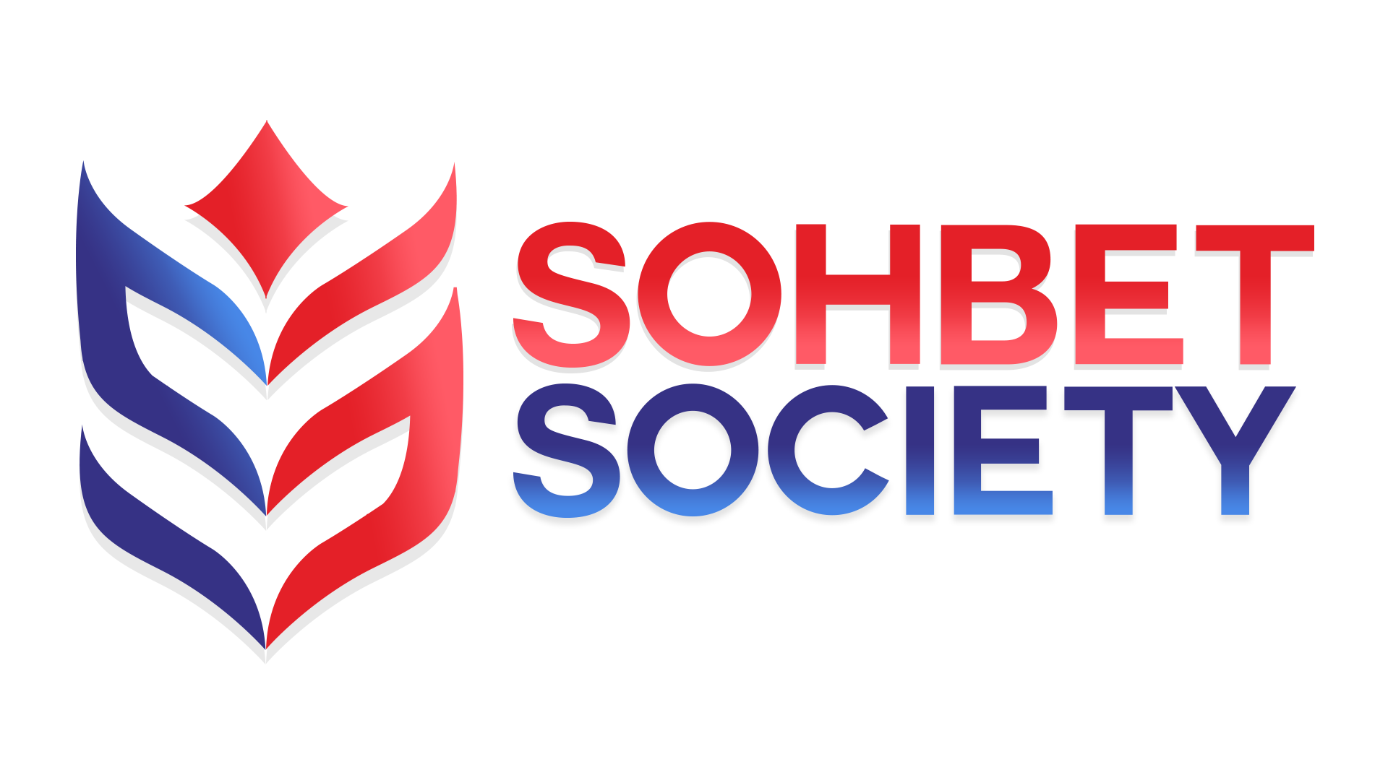

SOHBET SOCIETY
DISCRIMINATION POLICY

Equality Act, Adherence to Human Rights Act and Discrimination

Position Paper on Social Cohesion and Inclusion

- Sohbet Society is a London-based organisation dedicated to support youth in Britain with particular focus on BAME group.
- Sohbet Society is based community organisations.
- Sohbet Society has networks, skills, knowledge and experience to support and enable groups and individuals working for social cohesion and inclusion.

Principles

The following principles underline the approach of Sohbet Society in promoting social cohesion and inclusion. Our aim is to enable all members of society to participate fully in the life of their community:

- To promote and encourage participation by all people on issues affecting their lives so that they can express their needs and take a part in meeting those needs. Where barriers to participation exist, they must be challenged
- To recognise and celebrate the diversity that enriches communities and to encourage acceptance and tolerance of that diversity so that change may be pursued by collective action that uses the skills and experience of the whole community
- To maximise the opportunities for each person to realise their potential so they can be enabled and empowered to take control of their lives.

Equality Act

The previous legislation in relation to the range of discrimination was
encompassed in and replaced in October 2010 by the Equality Act. They were previously covered by various Acts. The purposes of the Act were to:

- Consolidate and strengthen anti-discrimination law;
- Replace the nine existing pieces of discrimination legislation with one set of rules
- Change some definitions and extend some coverage
- Achieve greater equality

The Act created the concepts of:

- Protected Characteristics
- Associated discrimination
- Perceptive discrimination
- Victimisation as a basis for a claim in its own right
- Instructing, causing or inducing discrimination

And it extended the definition of harassment

Protected Characteristics

There are nine. These are age, disability, gender reassignment, marriage and civil partnership, pregnancy and maternity, race, religion or belief, sex, and sexual orientation.

The Acts maintains the previous protections which individuals and groups enjoyed under all the previous legislation and provides that a person shall not be discriminated against, i.e. treated less favourably, on the grounds of any or all of the protected characteristics.

This is a key employment value to which all employees are expected to give their support.

Religion or Belief

One particular point of note is the inclusion of belief as a protected characteristic. Previously religion was included; however, this has now been extended to incorporate belief. Belief can be interpreted as a system of beliefs which has a structure and internal coherence. This means that it does not necessarily require a religious connection.

Race

The Act provides that people shall not be discriminated against on grounds of their colour, race, nationality or national or ethnic origin. Colour, race and nationality are straightforward enough, but it is the definition of “ethnic origin” which can causes confusion.

For a group to constitute an ethnic group, they must be regarded by others as a distinct community by virtue of certain characteristics. Some of these characteristics are essential; others are not essential but one or more of them will commonly be found and will help to distinguish the group from the surrounding community. The essential conditions are:

- A long-shared history of which the group is conscious as distinguishing it from other groups, and the memory of which it keeps alive;

- A cultural tradition of its own, including family and social customs and manners, often but not essentially associated with religious observance. In addition to these two essential characteristics the following characteristics are relevant:

- Either a common geographical origin, or descent from a small number of common ancestors

- A common language, not necessarily peculiar to the group.

- A common literature peculiar to the group;

- common religion different from that of the neighbouring groups or from the general community surrounding it;

- Being a minority or being an oppressed or a dominant group within a large community, for example a conquered people (say, inhabitants of England after the Norman Conquest) and their conquerors might both be ethnic groups.

Declaration of Intent on Racism

Sohbet Society recognises that England is a multi-racial society and believes that cultural diversity positively enriches our society.

Sohbet Society believes that no person or group should suffer disadvantages by reason of race or colour, and we declare our intention to work with others for the elimination of racial disadvantage and the promotion of racial justice.

In pursuit of its aims, Sohbet Society resolves to undertake a continuing review of all its policy and practice, and will in particular:

- Work to ensure that the services Sohbet Society provides are relevant and accessible to black and other ethnic minority groups.
- Work to ensure that Sohbet Society staffing/Volunteers reflects the multi-racial composition of our society.
- Work to increase the number of black and other ethnic minority organisations in membership of Sohbet Society.

Disability

The definition is largely unchanged as under DDA 1995 to protect disabled people from discrimination in different areas of life such as employment, education, and access to goods and services. However, there are some changes:

- The specific list of capacities removed. The disability simply has to be a physical or mental impairment which has a long-term and substantial effect on an individuals' ability to carry out day to day activities

- The concept of indirect disability discrimination introduced. This did not exist under the previous Disability Discrimination Act. It applies where a ‘provision, criterion or practice’ would put people of a claimant’s group, and claimant themselves, at a particular disadvantage unless it can be shown to be a ‘proportionate means of achieving a legitimate aim’

- The concept of ‘disability-related discrimination’ is replaced by the concept of ‘discrimination arising from disability’.

The Act also extends the prohibition on age discrimination to goods, facilities and services.

The previous Code of Practice for the elimination of discrimination in the field of employment against disabled persons or persons who have had a disability is still in operation and provides practical guidance on how discrimination can be eliminated, and frequent references to the Code are made in the text, which follows.

The legislation now sets out three ways in which disability discrimination may occur at work:

a) Where Sohbet Society, for a reason relating to a person’s disability, treats that person less favorably than he or she would treat someone else who does not have that disability

b) Where Sohbet Society fails to make reasonable adjustments to the workplace or working conditions to accommodate a disabled person.

c) Where Sohbet Society allows a ‘provision, criterion or practice’ that puts people of at a particular disadvantage unless it can be shown to be a ‘proportionate means of achieving a legitimate aim’

In these cases, Sohbet Society would be guilty of discrimination unless he or she can show that the behavior was justified. The Act specifically extends the duty to make reasonable adjustments to provide an auxiliary aid if without that aid the disabled person would be at a substantial disadvantage. However, that really simply reflects current practice.

Associate Discrimination

The Act introduces the concept of associate discrimination. This is where discrimination applies to someone who is associated with an individual who has with a protected characteristic and who is treated less favourably because of the protected characteristic. An example of this would be a parent who has a high sick absence record because they are caring for a disabled partner or child.

Perceptive Discrimination

This applies where discrimination occurs based on a mistaken perception that a person has a protected characteristic (with the exception of marriage or civil partnership). An example of this could be where an individual is discriminated from representing Sohbet Society because they are thought to look too young or old.

Victimisation

This is now a claim in own right. Previously it was subsumed within the other discrimination legislation. In addition, no comparator is now needed.

Instructing, Causing, or Inducing Discrimination

This is where an individual or group instructs, causes or induces either direct or indirect discrimination, harassment or victimisation. It applies to and is prohibited for all the protected characteristics

Harassment by a Third Party

Previously, this applies only to sexual harassment. However, the Act extended prevention of harassment by third party to other protected characteristics (with the exception of marriage and civil partnership, pregnancy and maternity). This will apply where more than two occasions occur if an employer is aware of the incidents (these are not necessarily same third party)

This also applies where the harassment related to a relevant protected characteristic i.e. associative or perception.

The Human Rights Act

Sohbet Society will work to promote and support adherence to The Human Rights Act 1998 (also known as the Act or the HRA) which came into force in the United Kingdom in October 2000.
The Act sets out the fundamental rights and freedoms that individuals in the UK have access to. They include:
- Right to life
- Freedom from torture and inhuman or degrading treatment
- Right to liberty and security
- Freedom from slavery and forced labour
- Right to a fair trial
- No punishment without law
- Respect for your private and family life, home and correspondence
- Freedom of thought, belief and religion
- Freedom of expression
- Freedom of assembly and association
- Right to marry and start a family
- Protection from discrimination in respect of these rights and freedoms
- Right to peaceful enjoyment of your property
- Right to education
- Right to participate in free elections

Equality and Diversity

We aim to be an organisation that values, recognises and responds to the diverse needs of members and those we serve. We adhere to the Equality Act 2010 and will not discriminate against any person or other organisation with particular reference to the protected characteristics.

Monitoring and Review

Review Date | 29/03/2021
Next Review Date | 29/03/2022
Review Author | AEK

