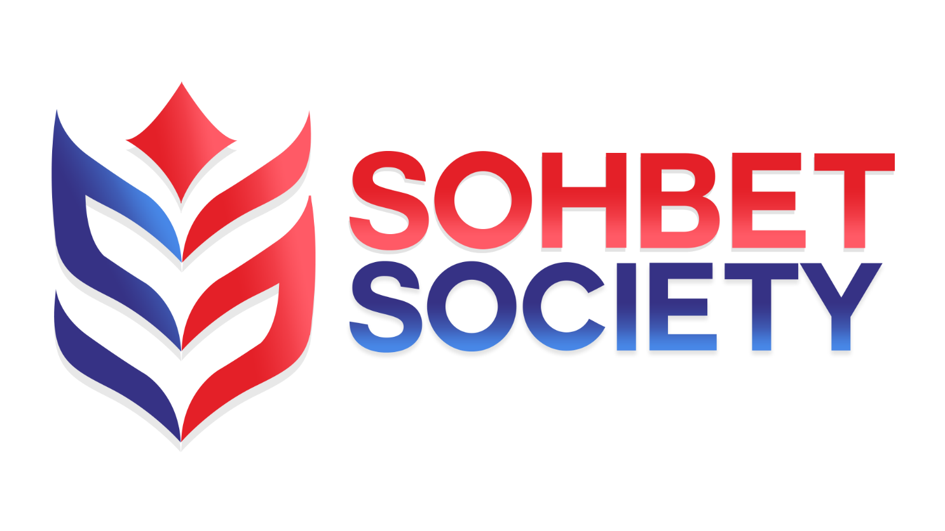

SOHBET SOCIETY
Disciplinary Policy and Procedures

Sohbet Society aims to be an organisation that values, recognises and responds to the diverse needs of members and those we serve. We adhere to the Equality Act 2010 and will not discriminate against any person or other organisation with particular reference to any of the protected characteristics.
- Purpose and scope
- It is essential that certain standards of conduct and performance are maintained to protect the smooth running of Sohbet Society and the wellbeing of all its employees. Sohbet Society’s Disciplinary Policy is intended to ensure fair and equitable treatment of employees where there are instances of misconduct or where job performance falls below an acceptable level.
- All employees are required to conduct themselves in a manner consistent with the effective and efficient operation of the organisation and should recognise and uphold high standards of conduct and performance in their dealings with each other, volunteers and members of the public who access our services. This Disciplinary Policy and its subsequent procedures therefore apply to all employees, irrespective of their length of service or role.
- This Disciplinary Policy and Procedures is for guidance only, does not form part of employees’ terms and conditions of employment and is therefore not contractually binding. Sohbet Society reserves the right to amend this policy from time to time and any changes will be communicated to and discussed with employees. Where appropriate, Sohbet Society aims to involve employees, and, where relevant, their representatives, in the development of this procedure. This procedure does not apply to cases involving genuine sickness absence, or proposed redundancies.
- Principles
- The procedure is designed to establish the facts quickly and to deal consistently with disciplinary issues. No disciplinary action will be taken until the matter has been fully investigated.
- Where an allegation of misconduct has been made or an employee appears to be under-performing, Sohbet Society’s first step will be to establish the facts as quickly as possible. The extent of the investigation required will vary according to the particular circumstances, but it may involve holding an investigatory meeting with the employee. During this investigation into the facts, Sohbet Society reserves the right to suspend the employee from their duties on full pay for a limited period of time, if this is deemed to be appropriate in the circumstances. Any such action will be confirmed to the employee in writing and kept under review. However, any investigation and/or suspension will be solely for the purpose of fact-finding and will not constitute disciplinary action. For the avoidance of doubt, no disciplinary decision will be taken until the disciplinary procedure detailed in this procedure has been followed.
- At every stage employees will be informed of what is alleged and have the opportunity to state their case at an investigatory meeting and be represented or accompanied, if they wish, by a trade union representative or a work colleague (they will be referred to as your “Chosen Companion”). Your chosen companion cannot be a related party either through direct family relations or a personal relationship (marriage/partner etc).
- An employee has the right to appeal against any disciplinary penalty.
- The Procedure
  - Informal disciplinary procedure
- For less serious misconduct or where performance levels are below standard, Sohbet Society may issue an oral warning after conducting an initial investigation without using the full disciplinary procedure. Examples of less serious misconduct or performance are minor breaches of organisation discipline, poor behaviour, poor timekeeping or poor job performance.
- An employee may if they wish be accompanied by a Chosen Companion of their choice to a meeting with their direct line manager under the informal procedure.
- An oral warning may be recorded on an employee's file by means of a written note. The note will remain on file for a period specified by the manager taking action (normally 6 months).
  - Formal disciplinary procedure
Stage 1 – formal verbal warning
If conduct or performance is unsatisfactory, the employee will be given a formal verbal warning or performance action plan. Such warnings will be recorded on file, but disregarded after 6 months of satisfactory service. The employee will be given a copy of the file note. The employee will also be informed that a formal written or final written warning may be considered if there is no sustained satisfactory improvement or change. (Where the first breach is sufficiently serious, for example because it is having, or is likely to have, a serious harmful effect on the organisation, it may be justifiable to move directly to a final written warning).
Stage 2 - formal written warning
A formal written warning is normally given when the misconduct or level of performance is more serious, but falls short of serious misconduct or a serious performance issue, or as an escalation from a formal verbal warning that has not corrected the misconduct or performance shortfall. The formal written warning will normally remain in force for a 6 month period.
In some cases, Sohbet Society may consider it appropriate to issue a second formal written warning, such as when a minor misconduct or performance issue has re-occurred following a formal verbal and first written warning.
Stage 3 – final written warning
Depending on the seriousness of the misconduct or level of the shortfall in performance level, this is the next stage after a first or any applicable second written warning. A final written warning can also be given in the first instance if the misconduct or performance issue is sufficiently serious. The warning will normally remain in force for a twelve month period.

Stage 4 – dismissal or action short of dismissal
If the conduct or performance has failed to improve or is of a serious enough nature, the employee may suffer demotion, disciplinary transfer, loss of seniority (as allowed in the contract) or dismissal (with or without notice or payment in lieu of notice, as appropriate).
  - Gross misconduct
If, after investigation and a disciplinary hearing, Sohbet Society considers that an employee has committed an offence of the following nature (the list is not exhaustive), the normal consequence will be dismissal without notice and without payment in lieu of notice:
Refusal to carry out a reasonable instruction; insulting, indecent or offensive behaviour; theft or attempted theft; damage to property; fraud, cheating or taking a bribe; incapacity for work due to being under the influence of alcohol or illegal drugs; physical violence; wilful giving of advice to voluntary community organisations without authorisation which is detrimental to Sohbet Society; bullying; conduct which causes, or has the potential to cause, serious reputational or public harm to Sohbet Society; safeguarding breached; gross insubordination; a criminal offence while employed which renders the employee unsuitable to carry out their duties; serious breach of data protection or confidentiality and/or committing any other offence of a similar gravity to the examples above.
While the alleged gross misconduct is being investigated, the employee may be suspended, during which time he or she will be paid their normal pay rate. Any decision to dismiss will be taken by the employer only after full investigation and a disciplinary hearing, at which the employee has had an opportunity to comment on the allegations.

Safeguarding breaches are an act of gross misconduct and will result in summary dismissal
- Appeals
An employee who wishes to appeal against any disciplinary decision must do so in writing to Sohbet Society’s Chief Executive or their nominee (normally line manager) within ten days of the disciplinary decision being confirmed to them in writing, stating the grounds upon which they intend to appeal.
Once notice of an employee’s appeal has been received, Sohbet Society will, within five working days, give the employee written notice of a date, time and place of the appeal meeting. The employee will be entitled to be accompanied at this meeting by their Chosen Companion.
A Panel from the Advisory Board of Sohbet Society’s Trustees will hear the appeal and decide the case as impartially as possible.
The decision of the appeal chairperson will be given to the employee in writing after the meeting. The chairperson’s decision is final, and there is no further right of appeal.

- Monitoring and review
The senior management team, with adequate consultation of the Board of Trustees, will regularly review the operation of this procedure.
- The Right to be Accompanied
The Employment Relations Act 1999 gives you the right to be accompanied by a fellow employee or trade union officer at any stage of the formal disciplinary procedure where that disciplinary meeting could result in:
- A formal warning being issued
- The taking of some other disciplinary action
- The confirmation of a warning or some other disciplinary action (e.g. an Appeal hearing)
You do not have the right to be accompanied by anyone else from outside the organisation. The right to be accompanied applied to employee who are not related, or in a relationship.

Review Date | 29/03/2021
Next Review Date | 29/03/2022
Review Author | MB

