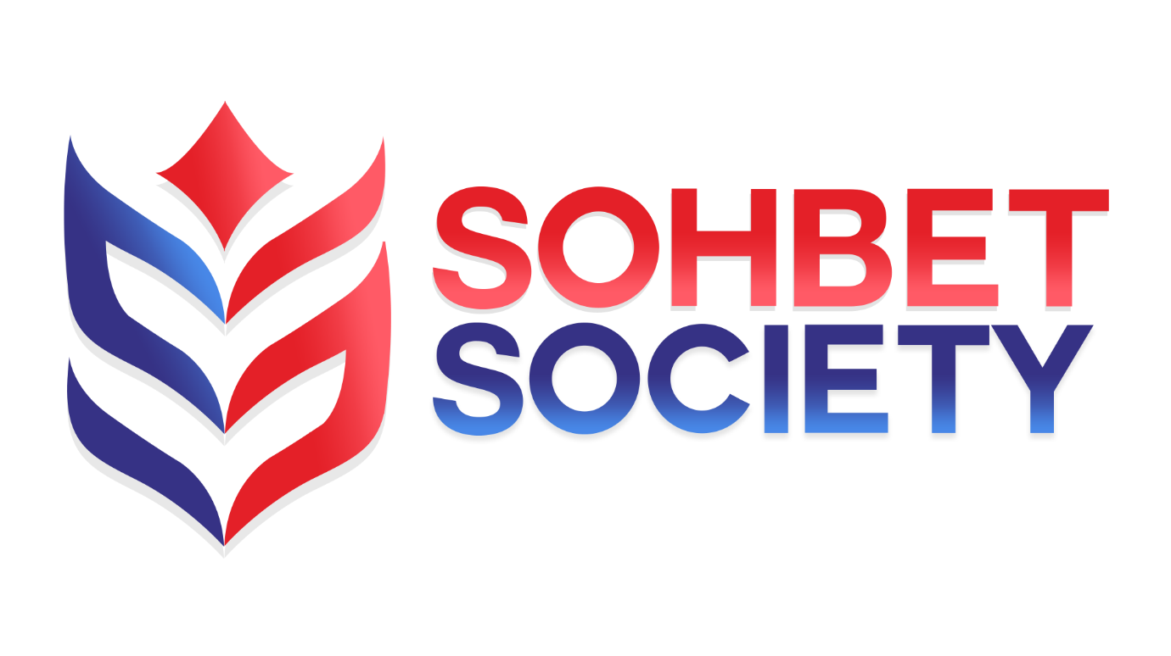

SOHBET SOCIETY
Complaints Policy

Our Policy
Sohbet Society conducts its business at all times with the highest standards of integrity and honesty and expects all its employees to maintain the same standards in everything they do.
Individuals, either working or volunteering for Time UK are therefore strongly encouraged to raise any concerns that they may have about the conduct of others in the charity or the way in which the charity is run.
The Whistleblowing Policy (133 KB) provides further information on how staff and volunteers should report a concern and sets out the ways in which Sohbet Society will investigate any issues arising from disclosure.
Stage 1-A: In the first instance, any concerns should be raised with the CEO, who will arrange an investigation of the matter. The investigation may involve you, and other individuals involved giving a written statement. Any investigation will be carried out in accordance with the principles set out above. Your statement will be taken into account, and you will be asked to comment on any additional evidence obtained. The CEO will take any necessary action, including reporting the matter to the Chair of the Board of Trustees and any appropriate government department or regulatory agency. The CEO will also invoke any disciplinary action required. On conclusion of any investigation, you will be told the outcome and what the charity has done, or proposes to do, about it. If no action is to be taken, the reason for this will be explained.
Stage 1-B: If you are concerned that the CEO is involved in the wrongdoing, has failed to make a proper investigation or has failed to report the outcome of the investigations to the relevant person, you should escalate the matter to the Chair of the Board of Trustees. The Chair will arrange for a review of the investigation to be carried out, make any necessary enquiries and make their own report to the Board.
Stage 2: If on the conclusion of stages 1-A or 1-B 2 you reasonably believe that the appropriate action has not been taken, you should report the matter to our Ombudsman who has been appointed to look into complaints about Sohbet Society and attempt to resolve them. Our Ombudsman (Willow Ombudsman) is independent, free and impartial – so they won’t take sides.
Stage 3: If on conclusion of stages 1 and 2, you reasonably believe that the appropriate action has not been taken, you should report the matter to the relevant body. This includes:
- HM Revenue and Customs (HMRC)
- The Health and Safety Executive
- The Environment Agency
- The Serious Fraud Office
- The Charity Commission
- The Pensions Regulator
- The Information Commissioner
- The Financial Conduct Authority.
You can find the full list in The Public Interest Disclosure (Prescribed Persons) Order 2014: https://www.gov.uk/government/uploads/system/uploads/attachment_data/file/496899/BIS-16-79-blowing-the-whistle-to-a-prescribed-person.pdf

Monitoring
Review Date | 01/02/2022
Next Review Date | 01/02/2023
Review Author | MB

